**FMCW Matlab simulation**

Chirp Generation, its time domain plot, N-point DFT plot and spectrogram.

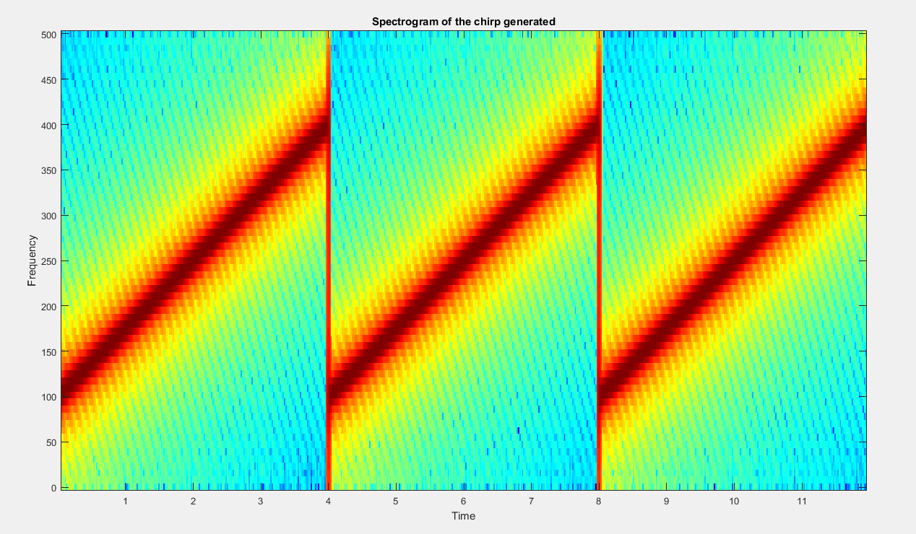

The bandwidth of the shown chirp is = [100 ---- 400] Hz ,i.e: 300 Hz. which is specified in the code.

Sweep time is 4 seconds , corresponding to this, the rate of change of frequency becomes

300/4 = 75 Hz/s

The following is the N-point DFT of the chirp. 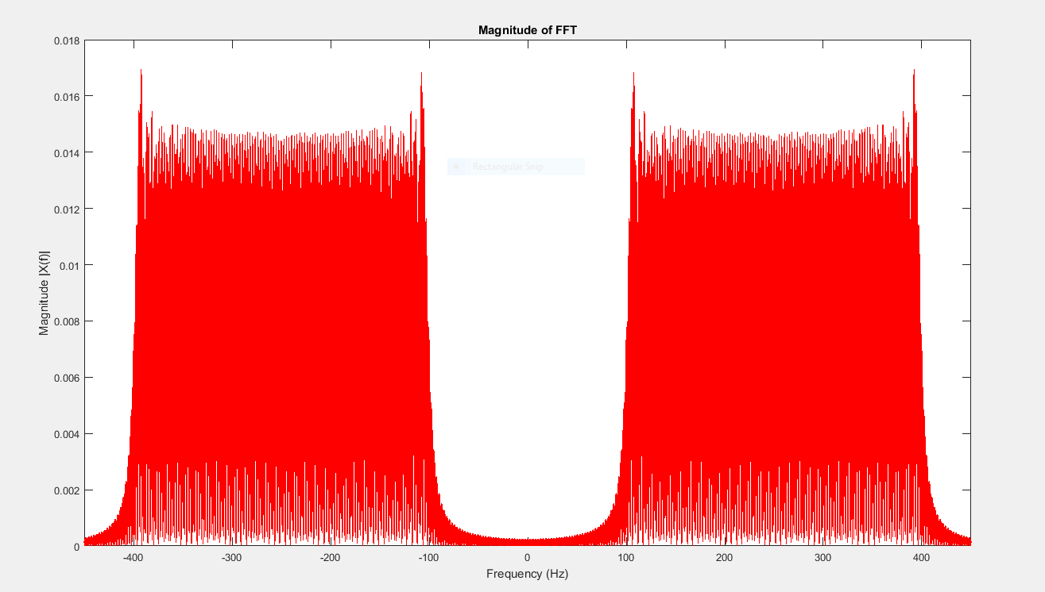

% parameters

fs=1000; %sampling frequency

t1=4; %% sweep time in seconds

t=0:1/fs:t1; %time base

tplot=[0:1/fs:t1 t1:1/fs:2*t1 2*t1:1/fs:3*t1]; % a time vector for three sweeps

f0=100;% starting frequency of the chirp

f1=400; %last frequency of the chirp

t0=t(1); %% initialize sweep time

T=t1-t0; %% sweep time

k=(f1-f0)/T; %%rate of change of frequency

x1=cos(2*pi*(k/2*t+f0).*t);% 1st chirp

x2=cos(2*pi*(k/2*t+f0).*t);% 2nd chirp

x3=cos(2*pi*(k/2*t+f0).*t);% 3rd chirp

x=[x1 x2 x3]; % % concatenating all three chirps into one vector

%%

% %% 1 sec polt of chirp%%

% figure

% plot(tplot,x,'k');

% title(['Chirp Signal']);

% xlabel('Time(s)');

% ylabel('Amplitude');

% DFT of the chirp to show its bandwidth

L=length(x); % length of 3 sweeps

NFFT = 16384; % N- point DFT

X = fftshift(fft(x,NFFT)); % DFT vector

f = fs*(-NFFT/2:NFFT/2-1)/NFFT; %Frequency Vector

figure

plot(f,abs(X)/(L),'r');

title('Magnitude of FFT');

xlabel('Frequency (Hz)')

ylabel('Magnitude |X(f)|');

xlim([-450 450]) % frequency axis limits

% spectrogram representation of the transmitted chirp

step=ceil(20*fs/1000); %% one spectral slice every 20 ms

window=ceil(100*fs/1000); %% 100 ms data window

[S, fx, t] = specgram(x);

figure

specgram(x, 2^nextpow2(window), fs, window, window-step);

title(['Spectrogram of the chirp generated']);

3 targets with different distances corresponding to three 3 different delays are assumed in the simulation.

So, this code generates those 3 reflection chirps and subtracts it from the transmitted chirp to get the IF signal. The IF signals are also shown as inhibiting only 1 frequency as a spike in its DFT.

Following is the reflected chirp for the nearest target , with a delay of about 400 milliseconds.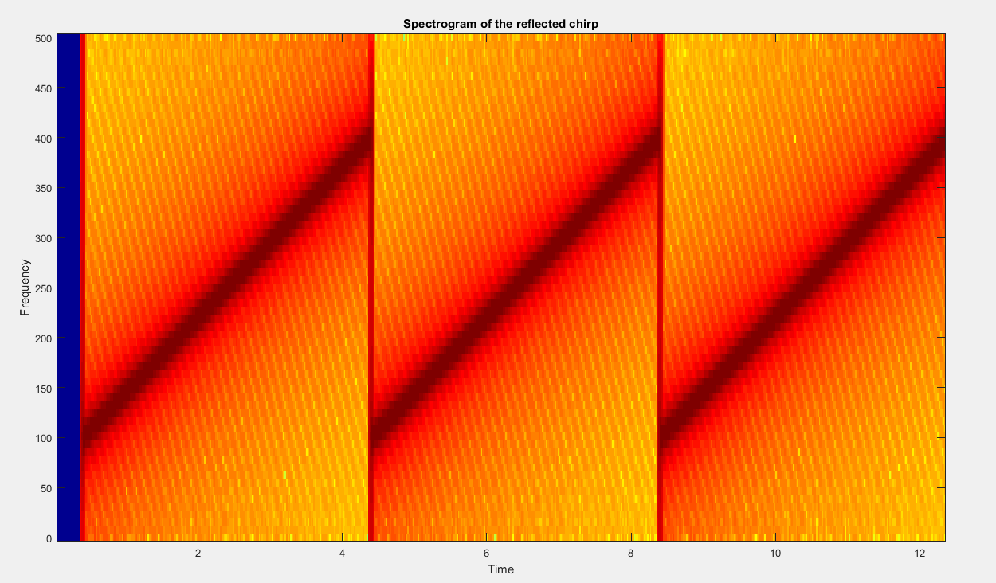

Here is the corresponding DFT showing a spike around 30 Hz, as it is the closest target.

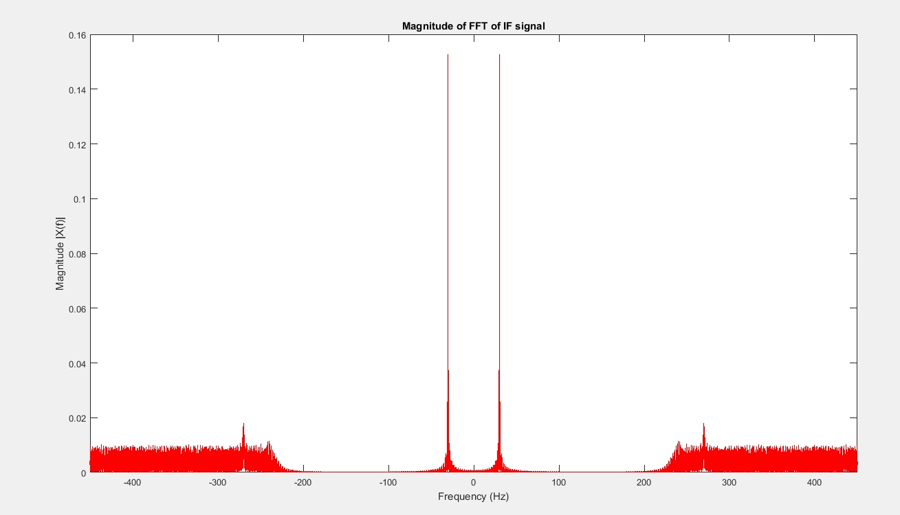

Here goes the reflected chirp for the 2nd target, whose delay is 1200 milliseconds, as shown in the spectrogram below.

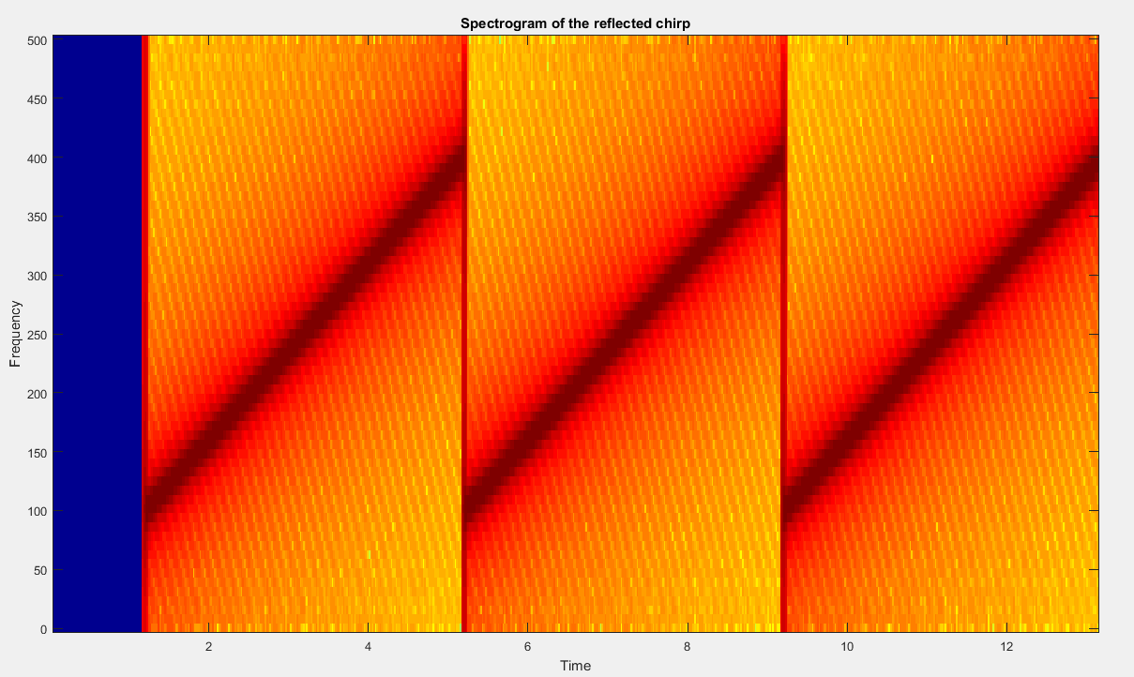

Corresponding DFT , having a spike at 100 Hz, which is more than the previous target as it is farther.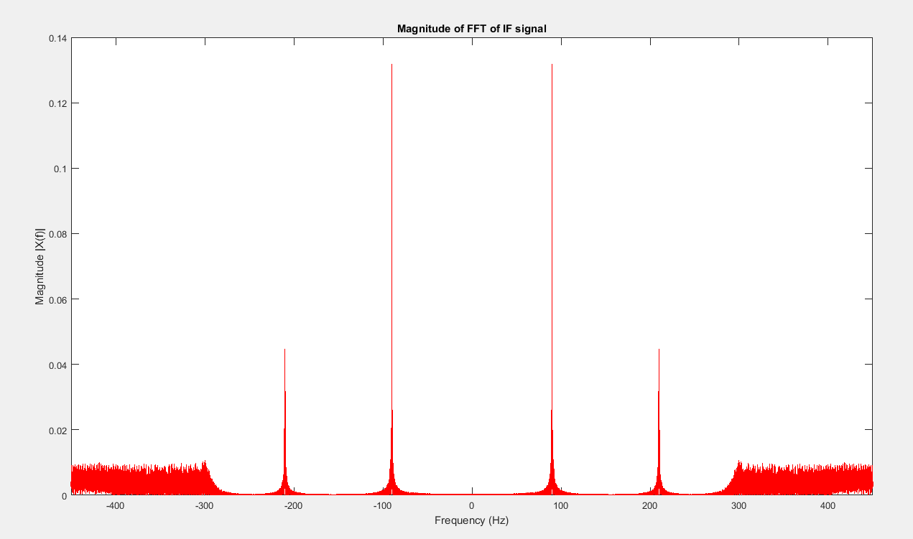

Finally, the reflected chirp for the 3rd target, whose delay is 2000 milliseconds, as shown in the spectrogram below.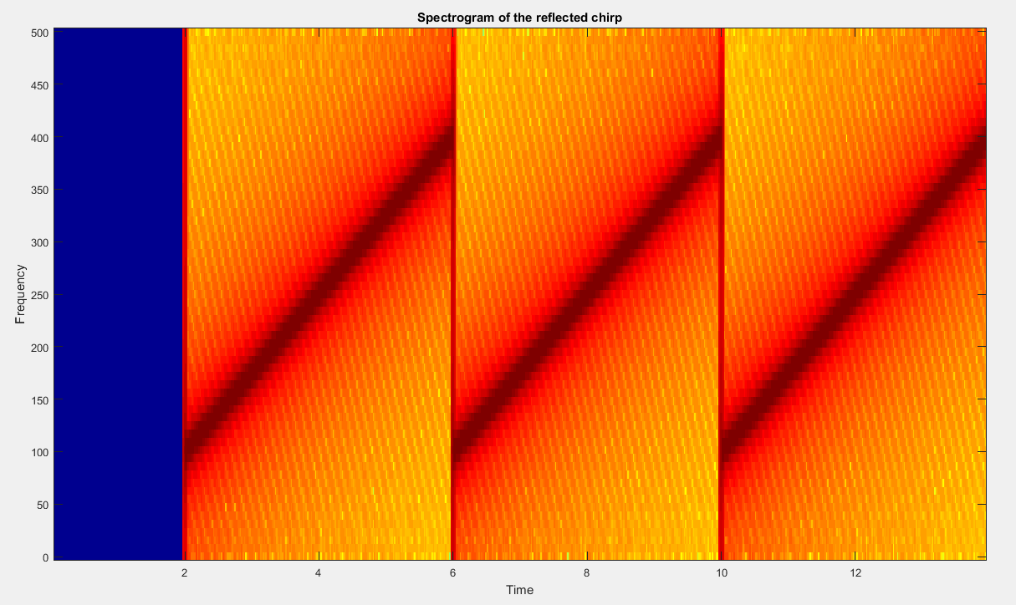

Corresponding DFT , having a spike at 150 Hz, which is more than the previous target as this one is the farthest target. SO as its delays is maximum, similarly the Frequency of the IF signal is also max.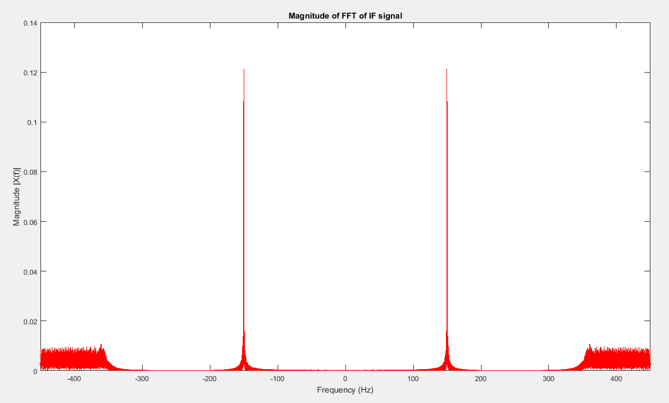

Code for the reflective targets modelling:

%%

%%reflections part

D=[400 1200 2000]; % modeling the delay of the 3 targets in milliseconds

for r = 1:3

tq=8+(D(r)/1000);

tref =[tplot 2*t1:1/fs:tq]; % time vector for each target

Z= zeros(1,D(r)+1); % appending zeros to equal the size of generated and reflected signal

X_refl = [Z x]; % a model of received signals with delays as shown

% figure

% plot(tref,X_refl,'k');

% title(['Reflected Chirp Signal']);

% xlabel('Time(s)');

% ylabel('Amplitude');

% spectrogram for the reflected signal

stepx=ceil(20*fs/1000); %% one spectral slice every 20 ms

windowx=ceil(100*fs/1000); %% 100 ms data window

[Sx, fxx, tref] = specgram(X_refl);

figure

specgram(X_refl, 2^nextpow2(windowx), fs, windowx, windowx-stepx);

title(['Spectrogram of the reflected chirp']);

%%

% IF signal (obtained by subtracting the recieved chirp from the sent one)

chirp_gen = [x Z]; % gene

X_IF= dechirp(X_refl',chirp_gen');

% % DFT of the IF signal

LL=length(X_IF');

NFFT = 16384;

XX = fftshift(fft(X_IF',NFFT));

ff = fs*(-NFFT/2:NFFT/2-1)/NFFT; %Frequency Vector

figure

plot(ff,abs(XX)/(LL),'r');

title('Magnitude of FFT of IF signal');

xlabel('Frequency (Hz)')

ylabel('Magnitude |X(f)|');

xlim([-450 450])

end

Finally the spectrogram of the IF signal is as follows,

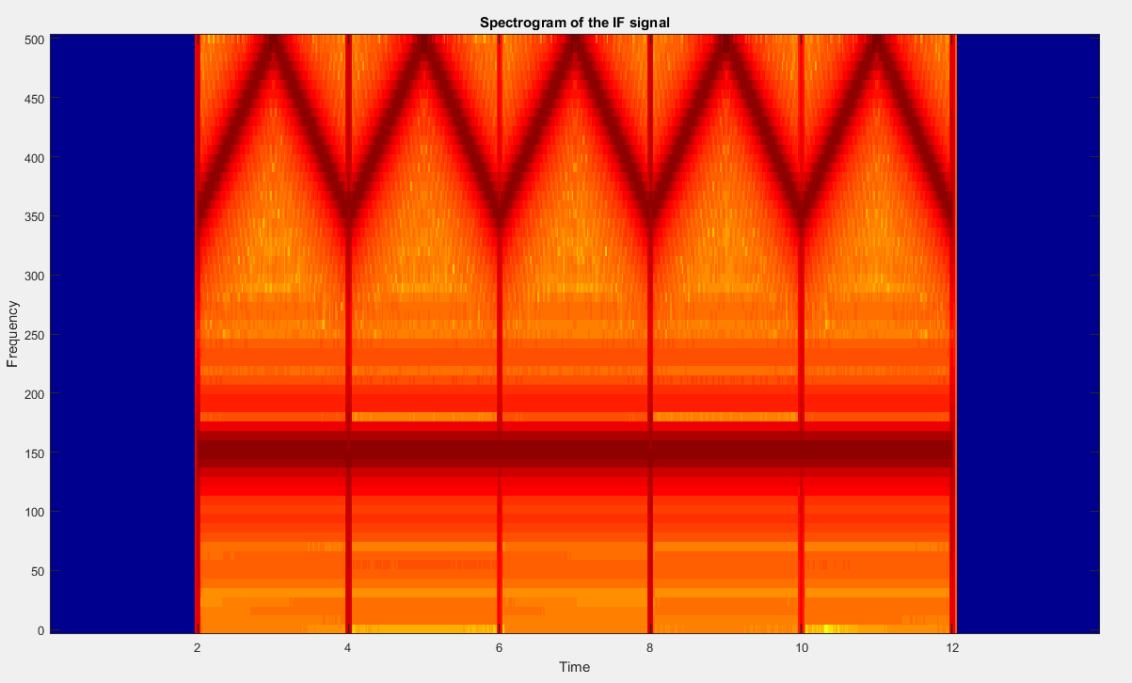

As shown that IF signal `s frequency at each instant is 150 for the 3rd target.

Code:

%%

% spectrogram for the IF signal

stepi=ceil(20*fs/1000); %% one spectral slice every 20 ms

windowi=ceil(100*fs/1000); %% 100 ms data window

[Si, fii, ti] = specgram(X_IF');

figure

specgram(X_IF', 2^nextpow2(windowi), fs, windowi, windowi-stepi);

title(['Spectrogram of the IF signal']);